Practical 7:

**Exercise 3:**

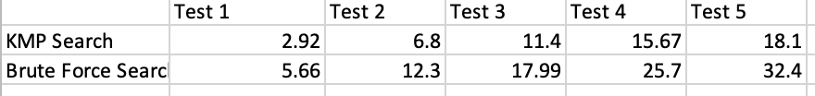

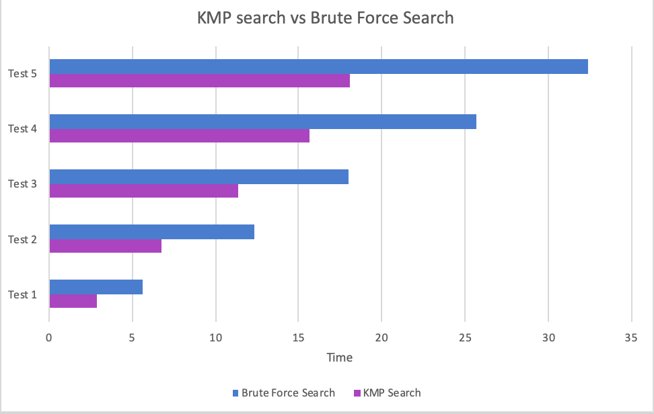

Graph to show the performance of brute force search vs KMP search. The KMP search algorithm performs at a faster speed comparing to the brute force search algorithm.

Q1. The time complexity for brute force search is O(n*m)

Q2. The time complexity for KMP search is O(n).